**AWS IAM SERVICE**

🡪OPEN THE IAM SERVICE

🡪ADD USER AND ENABLE IAM ACCESS AND GENERATE CUSTOM PASSWORD

🡪ADD THE PRIVILEGE AND DOWNLOAD CSV FILE AND LOGOUT

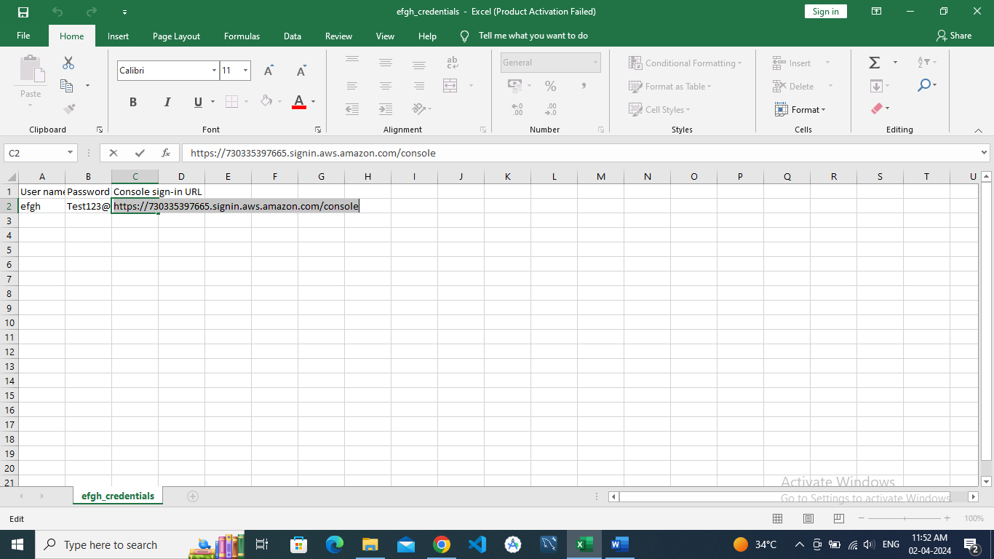

🡪LOGIN TO THE ACCOUNT

